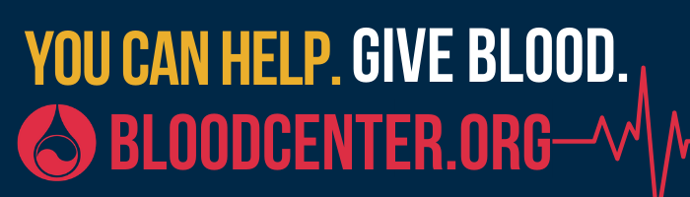 | FOR IMMEDIATE RELEASE  Mississippi Valley Regional Blood Center  CONTACT  Kirby Winn  Manager, Public Relations  kwinn@mvrbc.org | (563) 349-1571
Blood Center now requiring appointments during COVID-19 outbreak
Appointment schedules help MVRBC manage donor flow, maintain appropriate social distancing
(March 24, 2020 | Davenport, Iowa) – As communities across the Mississippi Valley Regional Blood Center (MVRBC) service region continue to manage the COVID-19 pandemic, the Blood Center is reminding donors that blood donation is an essential activity that is approved even as Stay at Home directives are in place. However, the Blood Center is moving to a policy of requiring appointments for blood donation. The new policy is intended to limit walk-in donations and will thereby help staff at donation centers manage donor flow and maintain appropriate social distancing between staff and donors.
In response to losses due to the COVID-19 pandemic, the Blood Center has expanded hours at many of its Donor Centers and is scheduling mobile blood drives to replace blood drives that have been cancelled. To find an opportunity to donate, please call MVRBC at (800) 747-5401 or schedule online at www.bloodcenter.org or via the Blood Center’s mobile app (info / download: www.bloodcenter.org/app).
Donor response to public appeals for blood donation has been strong over the last week, and this has helped the Blood Center maintain inventory levels even as it experiences a high rate of blood drive cancellations related to the COVID-19 pandemic. Nearly all blood drives scheduled to take place at high schools, colleges, and universities over the next six to eight weeks have been cancelled. Blood drives hosted by businesses have been significantly impacted as well, as nearly all workplaces adjust production schedules and implement work from home policies wherever possible.
“Ensuring that people have blood is required for health care to move forward, pandemic or no pandemic” said Dr. Louis Katz, the Blood Center’s Chief Medical Officer. “People with cancer, people with accidental trauma, people who need urgent surgery – the need for blood doesn’t go away just because there’s a pandemic, so we need robust supplies.” Dr. Katz is an infectious disease specialist who also serves as Medical Director for the Scott County, Iowa, Department of Public Health. For more of his message to blood donors, see: https://youtu.be/TC-GVRueo4A.
To provide a safe environment for blood donors, the Blood Center is:
- Posting signs at all facilities and collection events asking people not to present to blood drives, to donation centers, or to work if they are experiencing symptoms, if they have been exposed to someone who is being tested for COVID-19, if they have been tested for COVID-19. Scheduling staff are asking these screening questions when scheduling donors over the phone as well.
- Requiring an appointment for blood donation, rather than accepting walk-ins. This help manage the flow of donor presentation to avoid having too many people at a blood drive or donation center at any one time.
- Prior to donation, donors are asked screened for symptoms of illness (body temperature, heart rate, blood pressure, and hemoglobin level all are checked, and the donor completes a pre-donation Donor History Questionnaire).
- Reiterating existing protocols for keeping environments safe and healthy for workers and donors and are expanding upon existing cleaning and health hygiene practices.
-more-

- Donor Services (blood collection) staff are already required to change gloves between donors.
- Maintaining appropriate (six feet) social distancing between staff and donors as much as possible, while recognizing certain interactions in pre-donation screening and phlebotomy require contact between staff and donor
- Ensuring hand sanitizer is available at all stations at blood collection events.
- Staff at collection events and all facilities are being asked to frequently clean high-touch surfaces.
- Donors are encouraged to use EarlyQ pre-donation screening when possible on the day of donation and to make and keep appointments to moderate the flow of donors through collection operations. (www.bloodcenter.org/earlyq)
About Mississippi Valley Regional Blood Center
Mississippi Valley Regional Blood Center (MVRBC), based in Davenport, Iowa, serves 115 hospitals in Illinois, Iowa, Missouri and Wisconsin, as well as resource sharing partners across the country. Locally, MVRBC is the provider to hospitals in Burlington, Clinton, Dubuque, Galesburg, Geneseo, Muscatine, and the Quad Cities, including Genesis Health System, UnityPoint Health, Select Specialty Hospital, Hammond Henry Hospital, OSF HealthCare Saint Mary Medical Center, Great River Health System, and Mercy Clinton.
The Blood Center’s service region extends from southwestern Wisconsin to St. Louis, Missouri and from Danville, Illinois to Chariton, Iowa. For more information, see www.bloodcenter.org and visit the Blood Center’s social media channels: www.facebook.com/MVRBC, www.twitter.com/willyougive, www.youtube.com/MVRBC, and www.instagram.com/willyougive/.

-end-

